**I.** Slope – intercept form of a line is a linear equation that is solved for the “y” variable.

slope-intercept form: ­­­­­­­­­­­­­­­­­­­___________________________

“m” is ___________________________________________________________________

________________________________________________________________________

“b” is ____________________________________________________________________

_________________________________________________________________________

Use your graphing calculator to take a look at slope of lines:

All equations must be in slope-intercept form in order to type it in the calculator.

**y = y1: (type your equation) graph**

**ZOOM 6: standard**

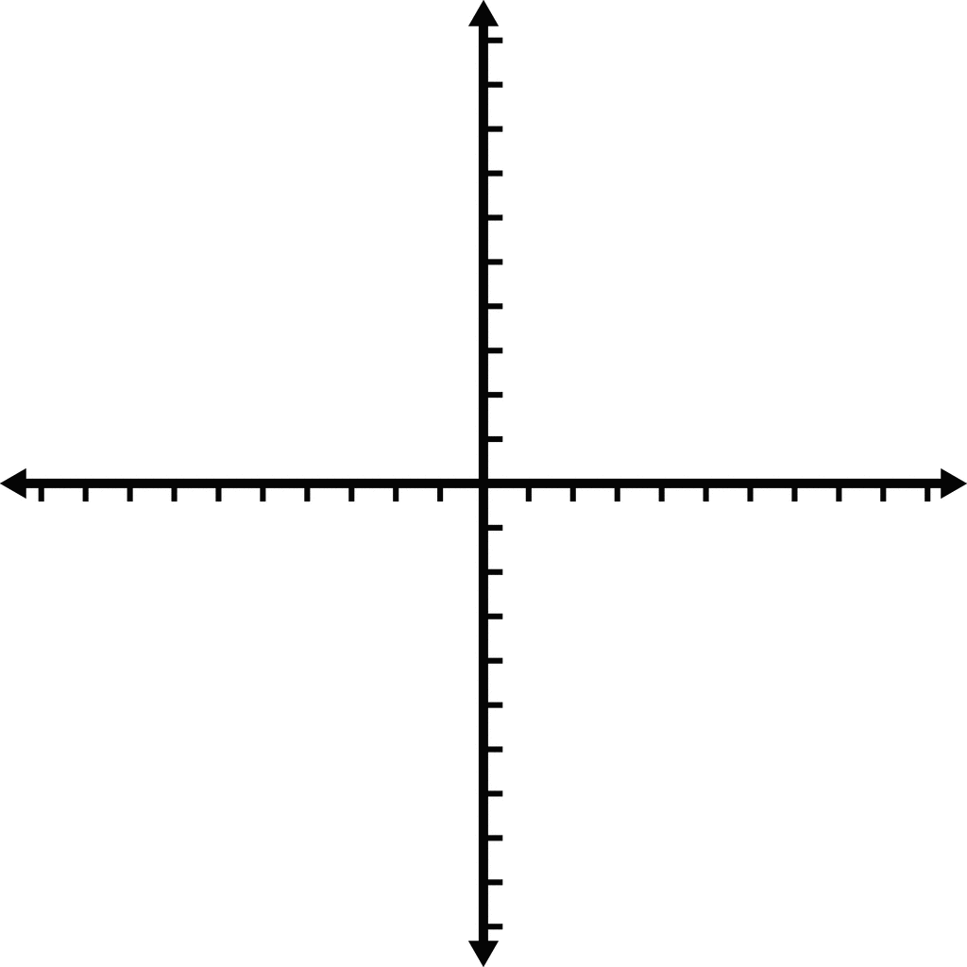



y = 2x + 3 y = –2x + 3



y = 2x – 3 y = –2x – 3



y = 2x y = –2x



y = 3 y = –3

**EXAMPLE:** Use slope and y-intercept to write a linear equation.

Write an equation of a line in slope-intercept form using the given information:

$1) slope=5 and y-intercept is (0 , 15)$

$2) slope=\frac{3}{4} and y-intercept is \left(0 , \frac{2}{3}\right)$

$3) slope=-2 and y-intercept is (0 , -12)$

$4) m=-1 and b=-2$

_______________________________

_______________________________

_______________________________

_______________________________

**EXAMPLE:** Write the slope (m) and y-intercept (b) for each linear equation.

$$1) y= -\frac{5}{2}x+5$$

$$3) y= -4x-4$$

$$5) 2x+y=1$$

$$7) 8x+3y=-9$$

$$2) y= -x+3$$

$$4) y=-6$$

$$6) 15x+5y=-10$$

$$8) 4x-5y=0$$